LCSRA Referee Apparel Announcement 2026:
The LCSRA Board is willing to help pay for fleece pullovers/jackets for LCSRA members. The clothing would have a stitched LCSRA logo. Embroider initials or names are also an option ($6.00). Prices vary and the association will cover $25 for one clothing item per member. Plus sizes are available for a slightly higher cost. Orders will be taken in 3 batches. 1st deadline August 1, 2026, 2nd deadline August 30, 2026, 3rd deadline September 30, 2026. The clothing will be available 7-10 days after the order is placed. The balance due will be deducted from fall game fees. The Board recommends any of the following:
You can check details at www.sanmar.com or call Rich Kelly (cell: 541-517-9388).
ORDER FORM: Name________________________________ Cell ________________________ Email _____________________________
Optional – embroidered name or initials ($6.00)_________________________________________________________________
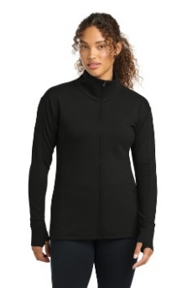
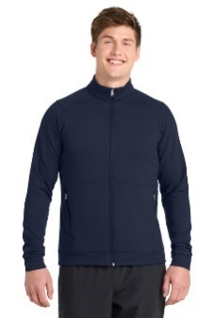
Circle the desired item and size. Return order form to Rich Kelly.

ST560 or LST560, Heavy weight jacket(7.4 ounce), full zip, M/W –
XS-S-M-L-XL = $45.45 2X = $47.00
3X = $50.00
4X = $51.50
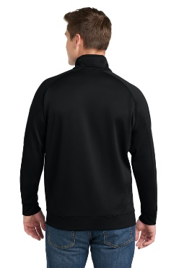
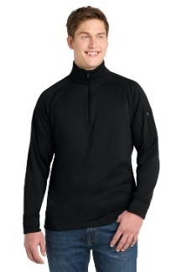
F247, Heavy/medium weight pullover(7.1 ounce), ¼ zip, unisex
XS-S-M-L-XL = $50.50 2X = $52.00
3X = $55.00
4X = $56.50

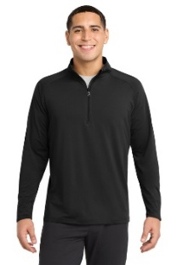
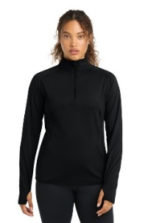
ST850 or LST850, Medium weight pullover(6.8 ounce), ¼ zip, M/W
XS-S-M-L-XL = $39.90 2X = $41.40
3X = $44.40
4X = $45.90
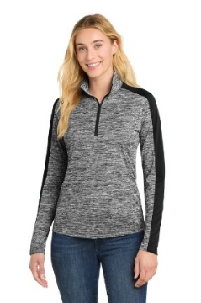
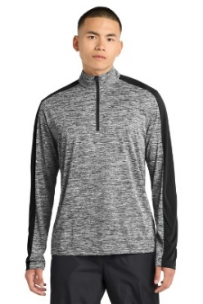
ST397 or LST397, Lightweight pullover(4.1 ounce), ¼ zip, M/W
XS-S-M-L-XL = $28.75 2X = $30.25
3X = $33.25
4X = $34.25

